Chapter 14, Solution 56.

- From Eq 14.54,
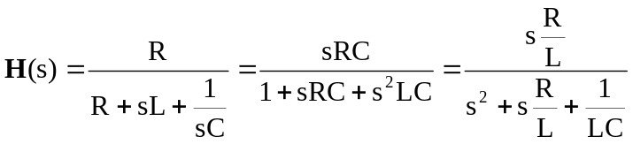

Since 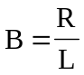 and 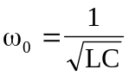,
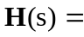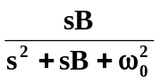

- From Eq. 14.56,
